CLOUD COMPUTING

TASK 5.1P

Creating a Virtual Private Cloud

**Task 1: Creating a VPC**

A **VPC (Virtual Private Cloud)** is your own isolated network within AWS.

* **Why:** It allows you to deploy AWS resources in a secure and customizable environment.
* **What you did:**
  + Created a VPC with CIDR block 10.0.0.0/16 (65,536 IPs).
  + Enabled DNS hostnames for EC2 instances for easier access using domain names.

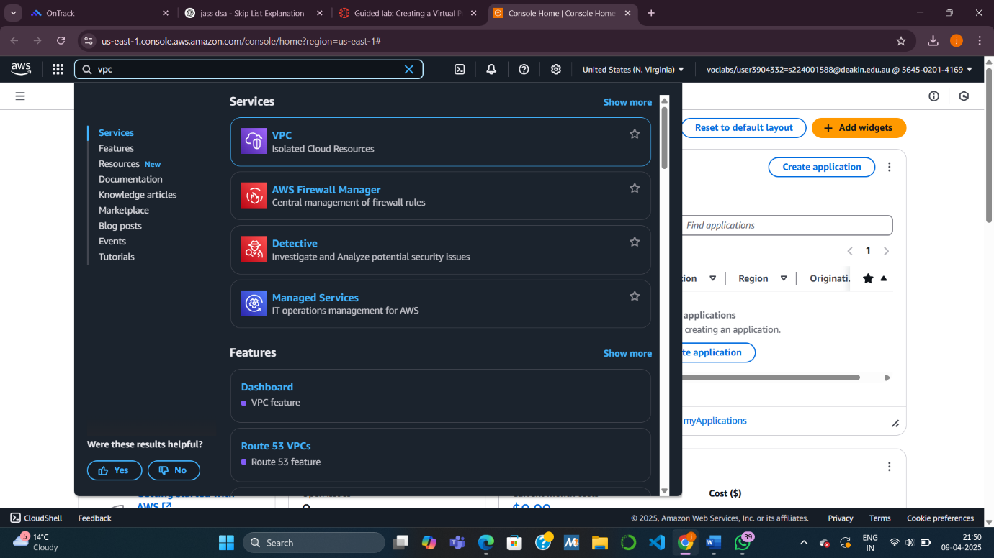

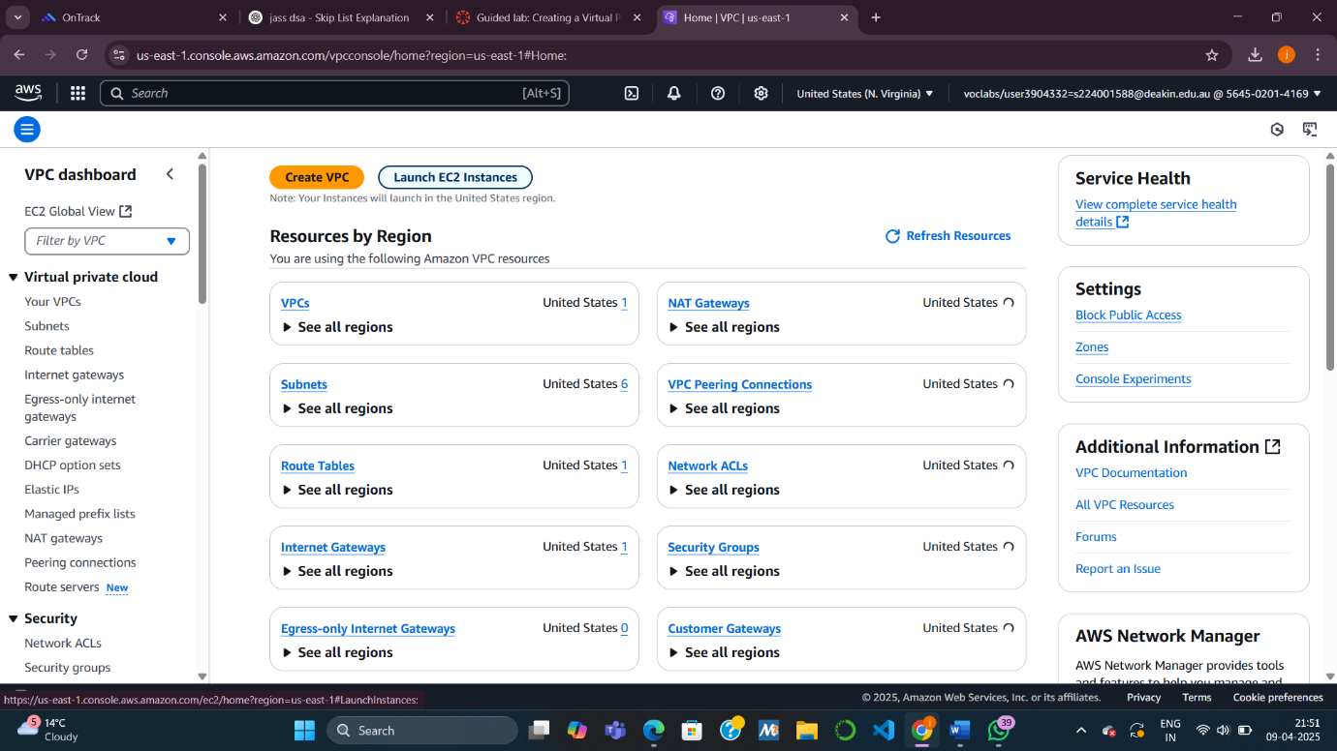

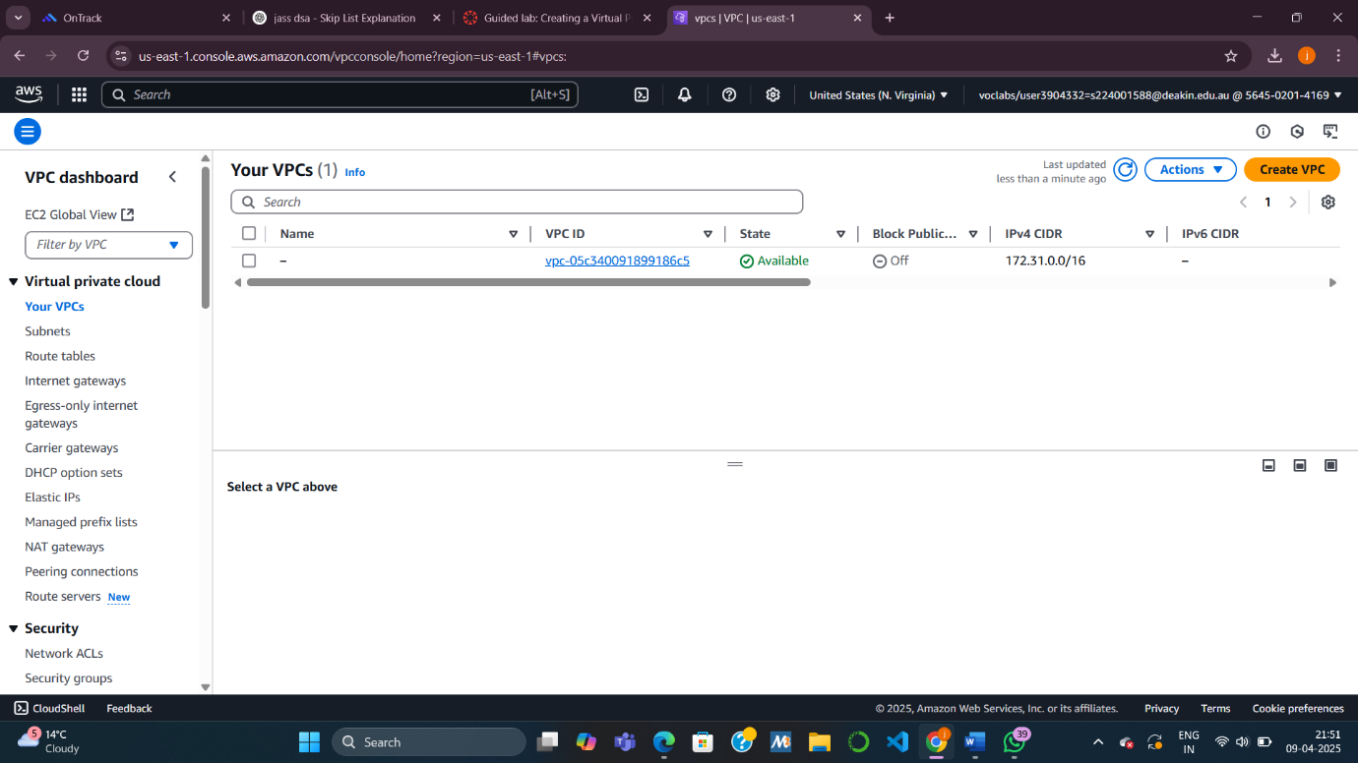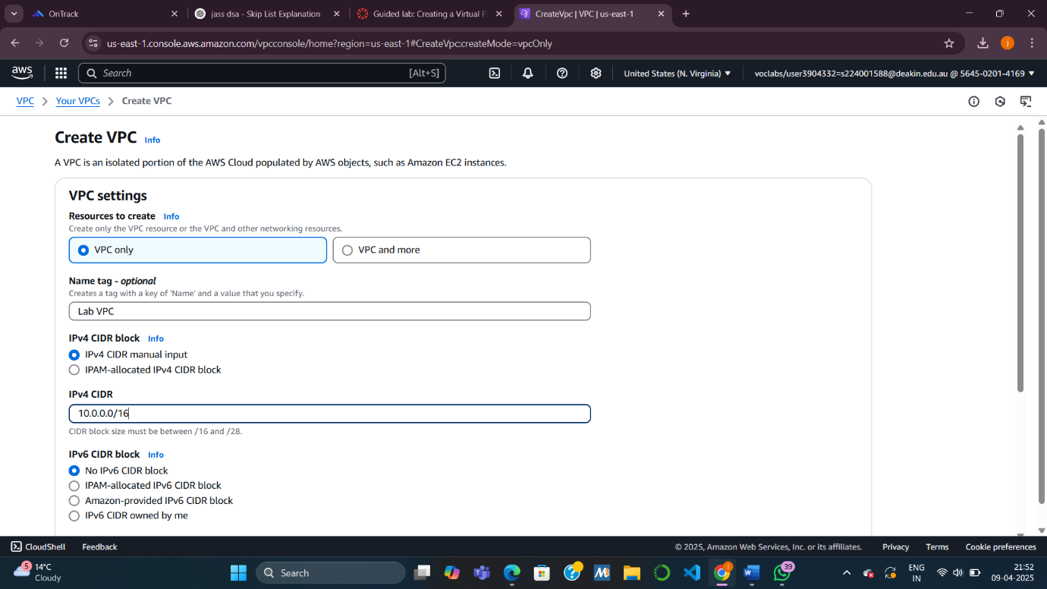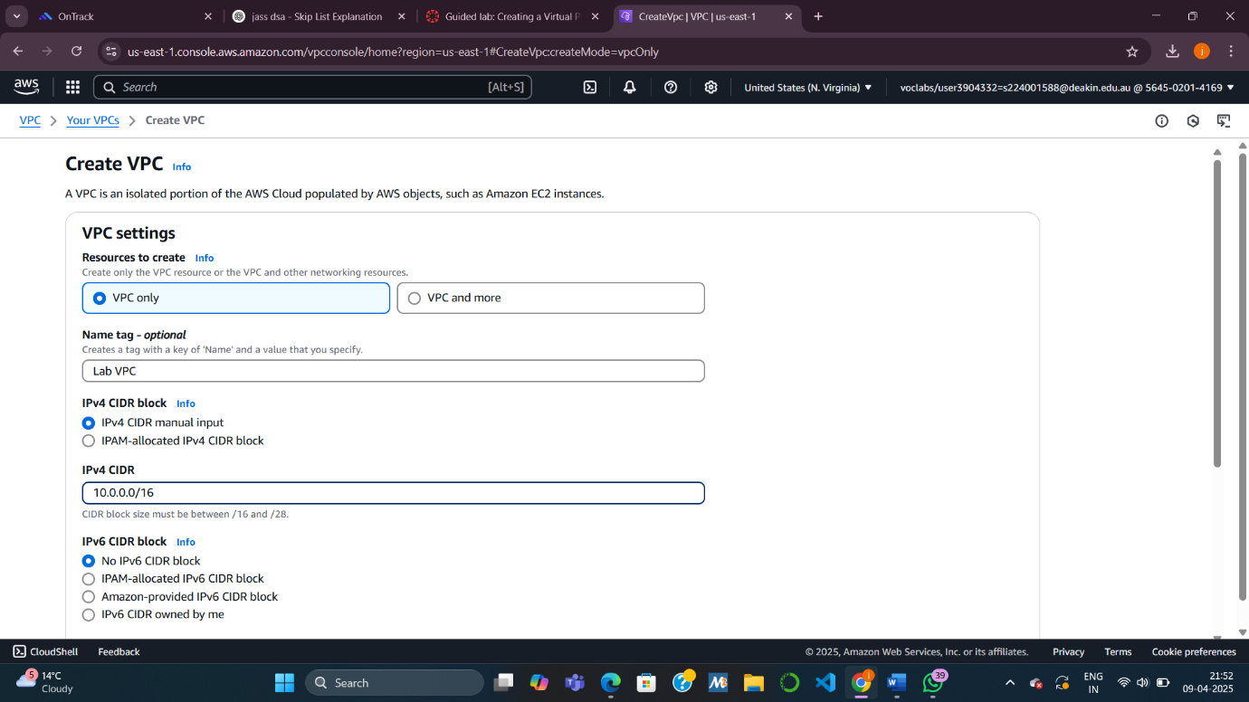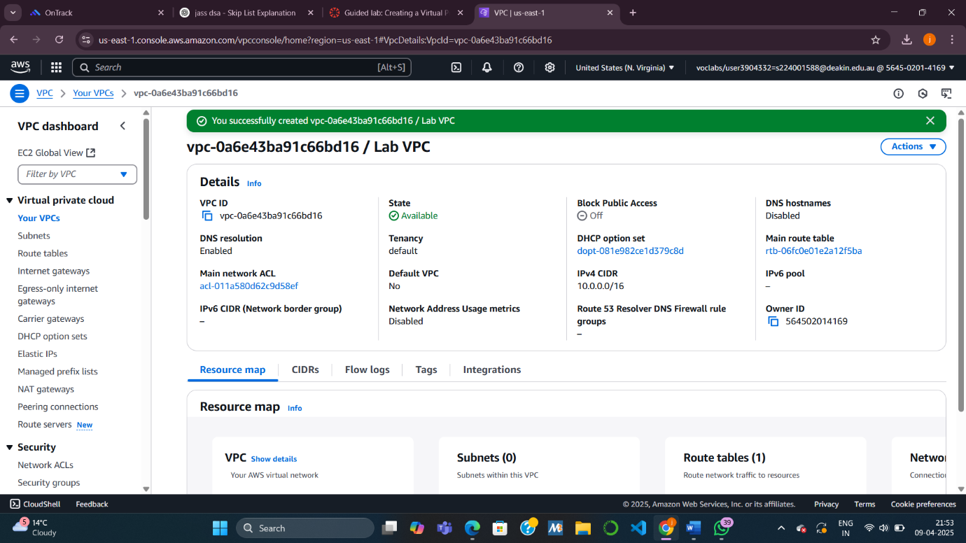



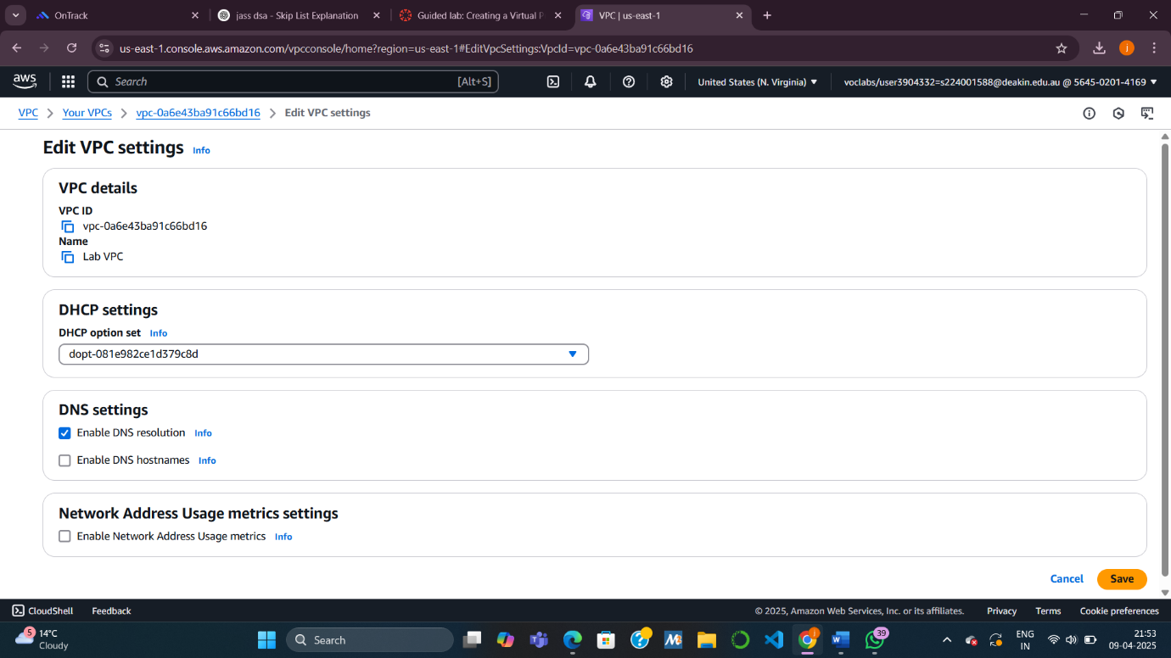

**Task 2: Creating Subnets**

Subnets divide your VPC into smaller segments.

**2.1 Creating a Public Subnet**

* **Why:** Public subnets are for resources that need internet access (e.g., web servers).
* **What you did:**
  + Created a subnet with CIDR block 10.0.0.0/24 (256 IPs).
  + Enabled auto-assign public IP so instances launched here get internet access.

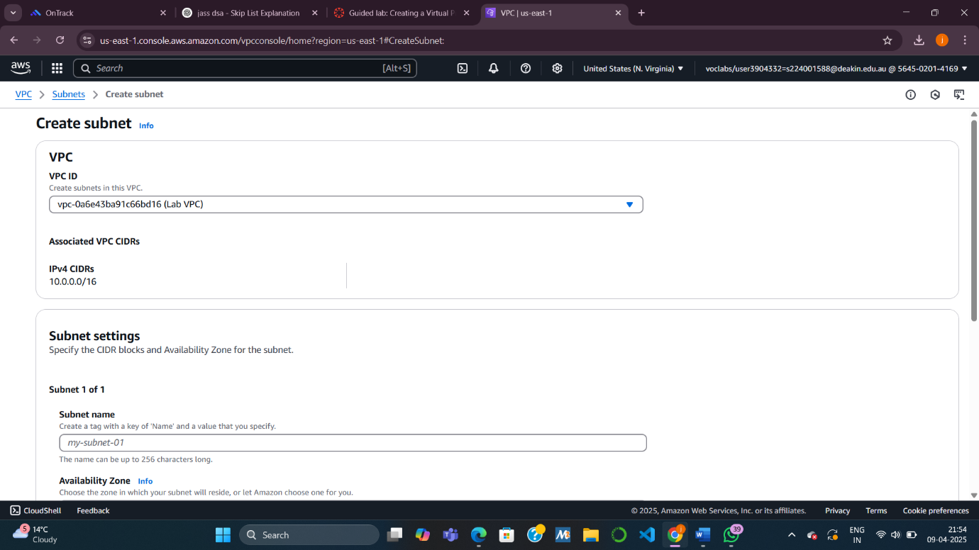



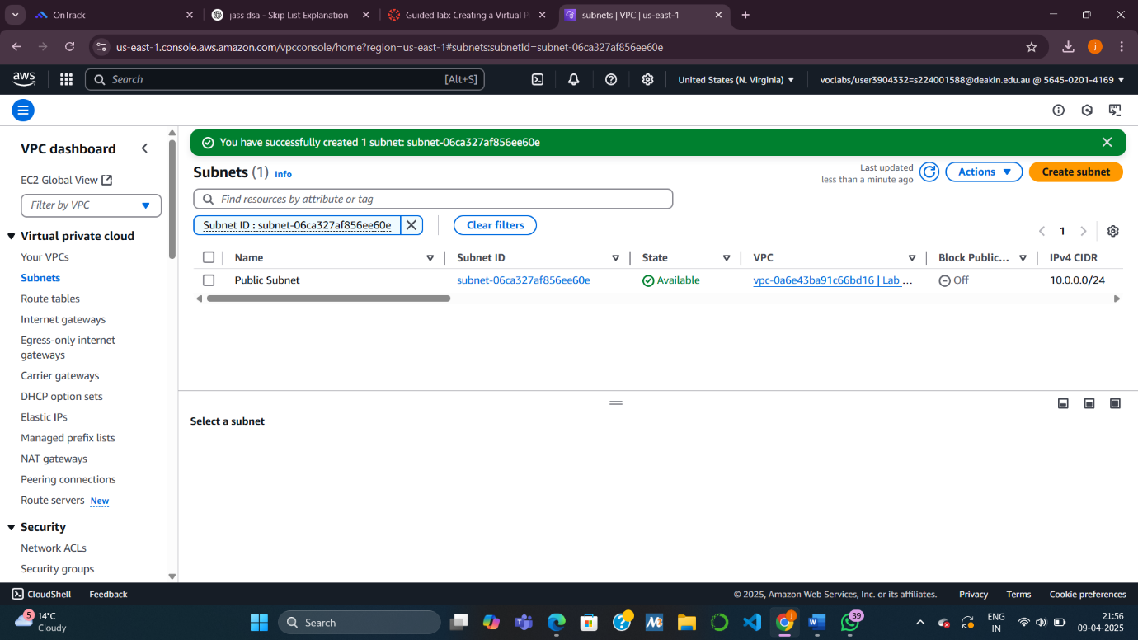

**2.2 Creating a Private Subnet**

* **Why:** Private subnets are for internal resources (e.g., databases).
* **What you did:**
  + Created a subnet with CIDR block 10.0.2.0/23 (512 IPs).
  + This subnet has no public access by default.

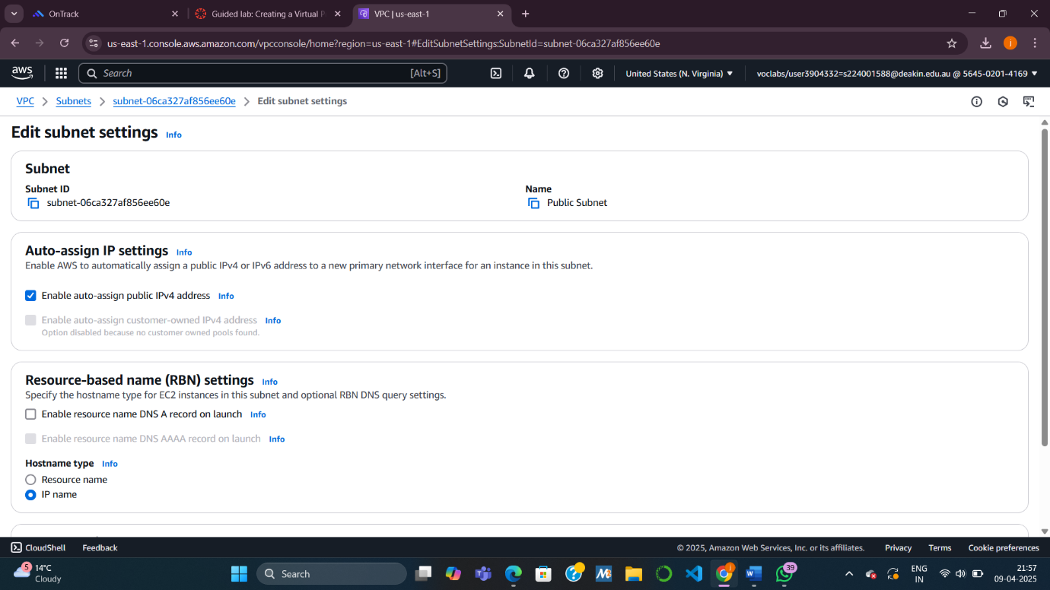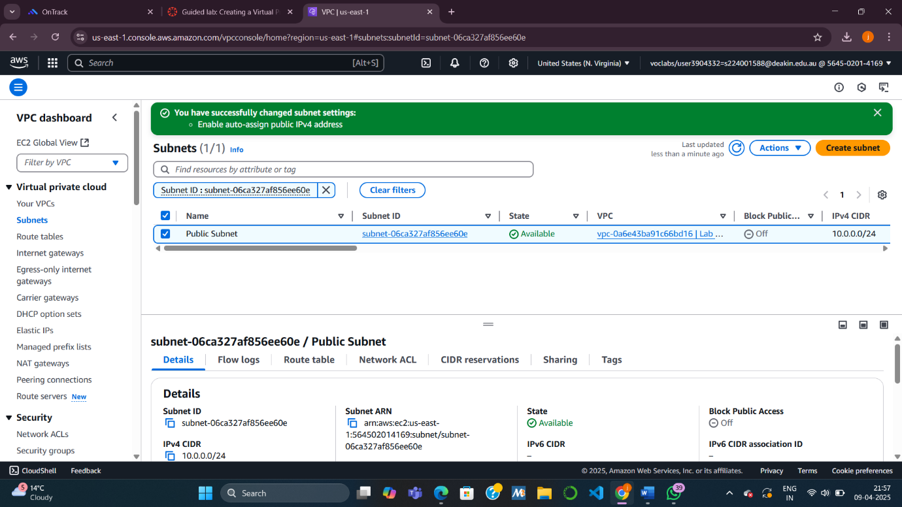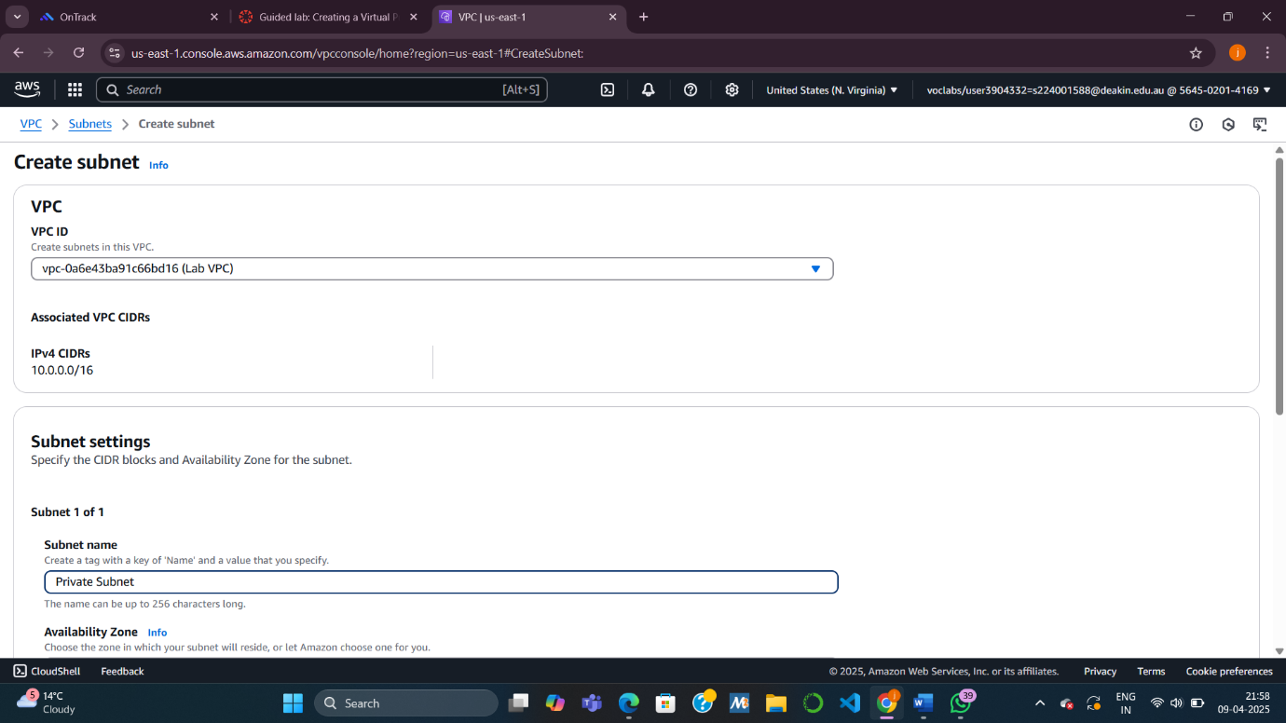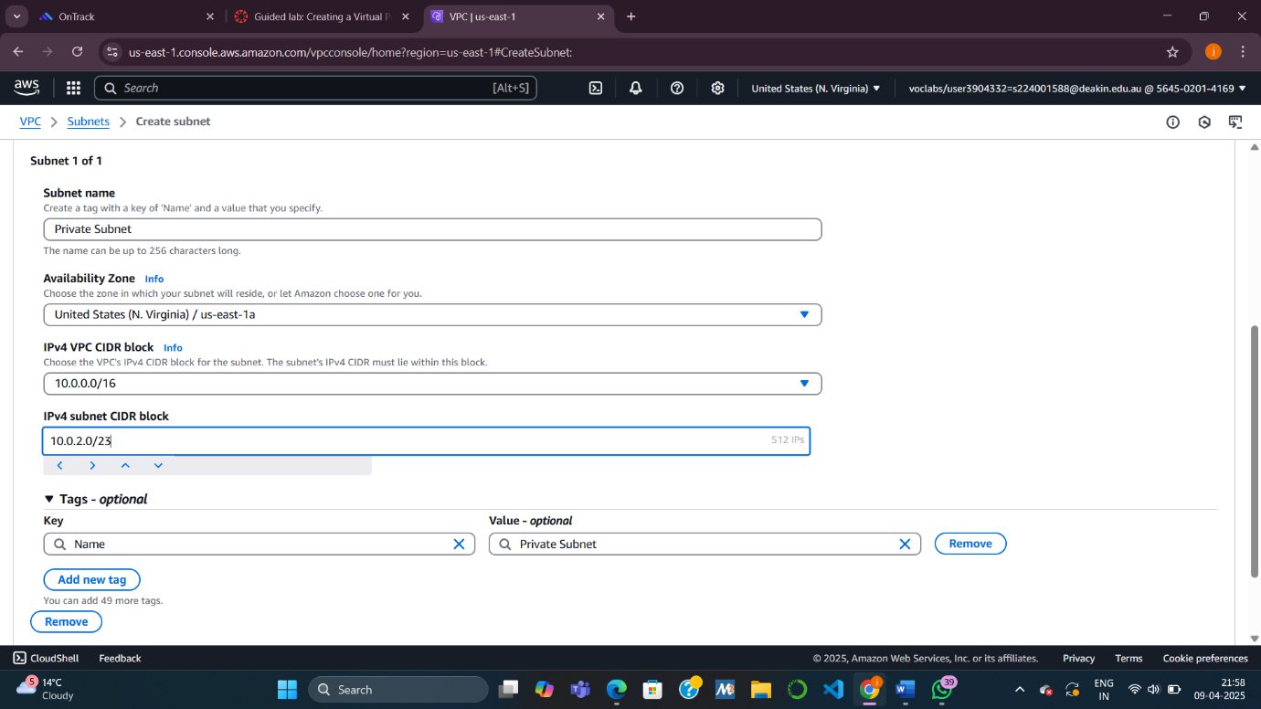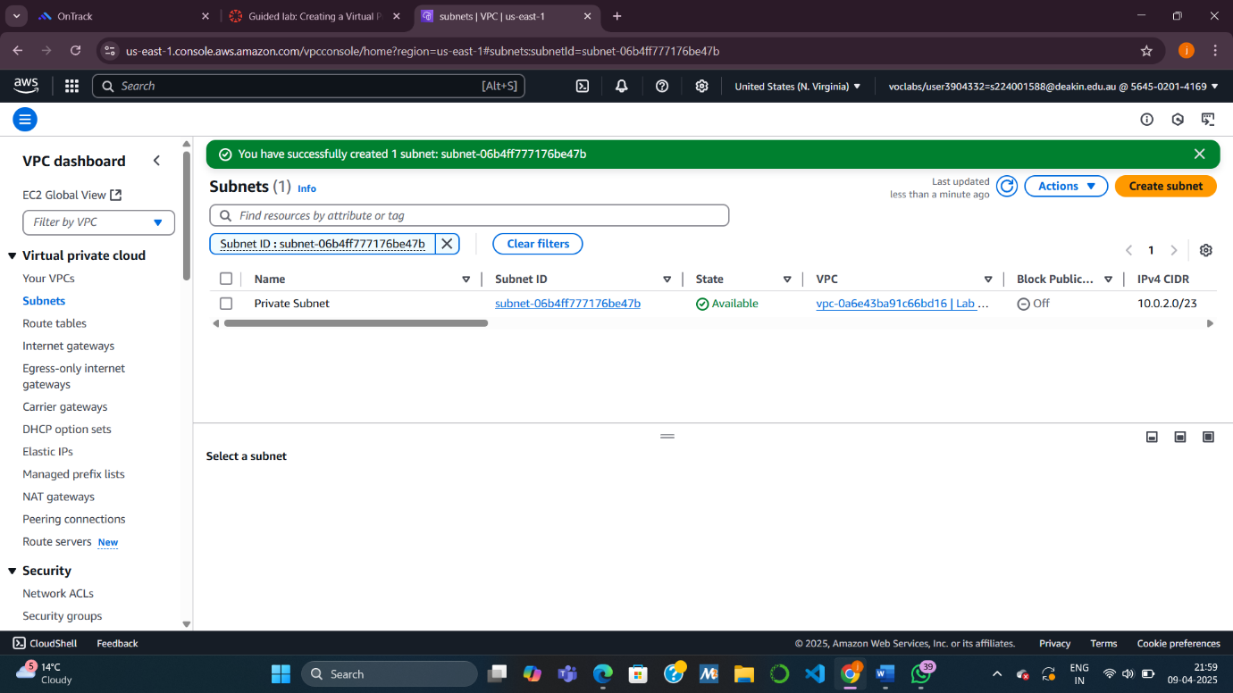

**Task 3: Creating an Internet Gateway**

An **Internet Gateway (IGW)** connects your VPC to the internet.

* **Why:** Required for instances in the public subnet to access the internet.
* **What you did:**
  + Created and attached the IGW to your VPC.

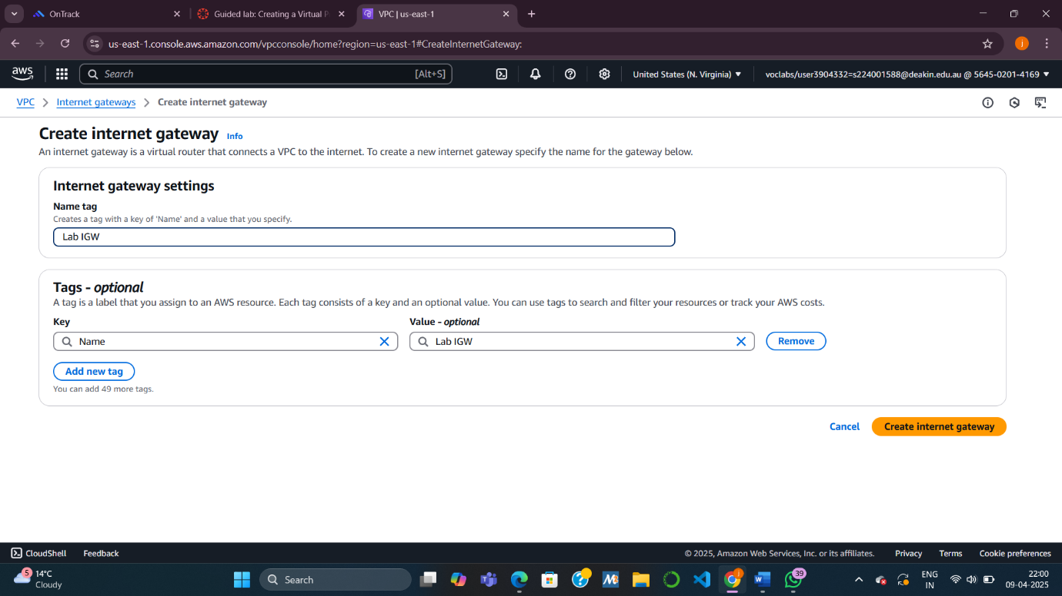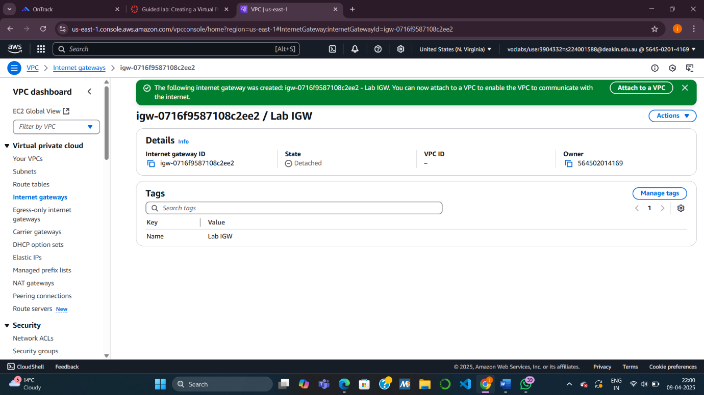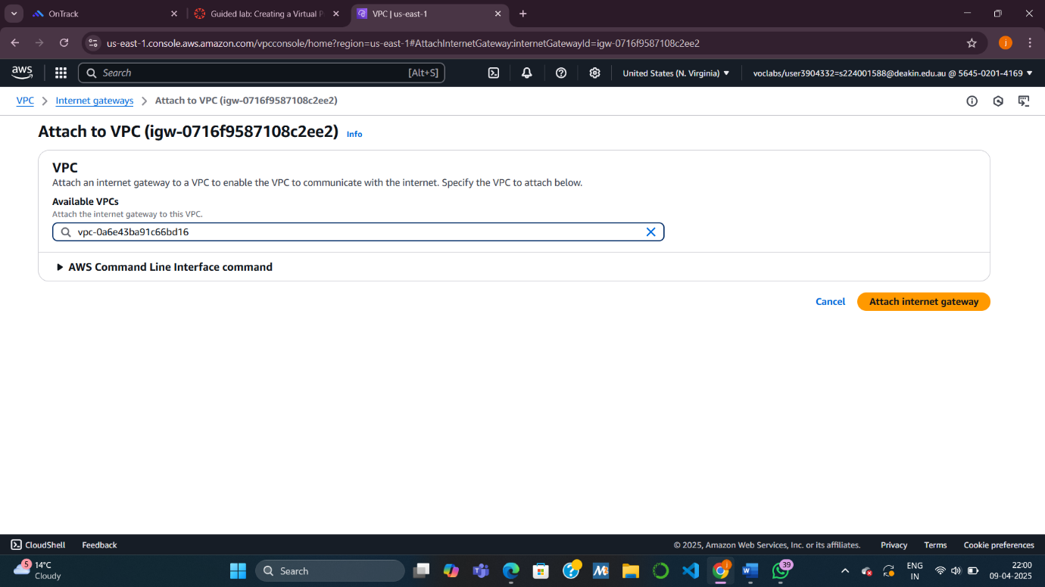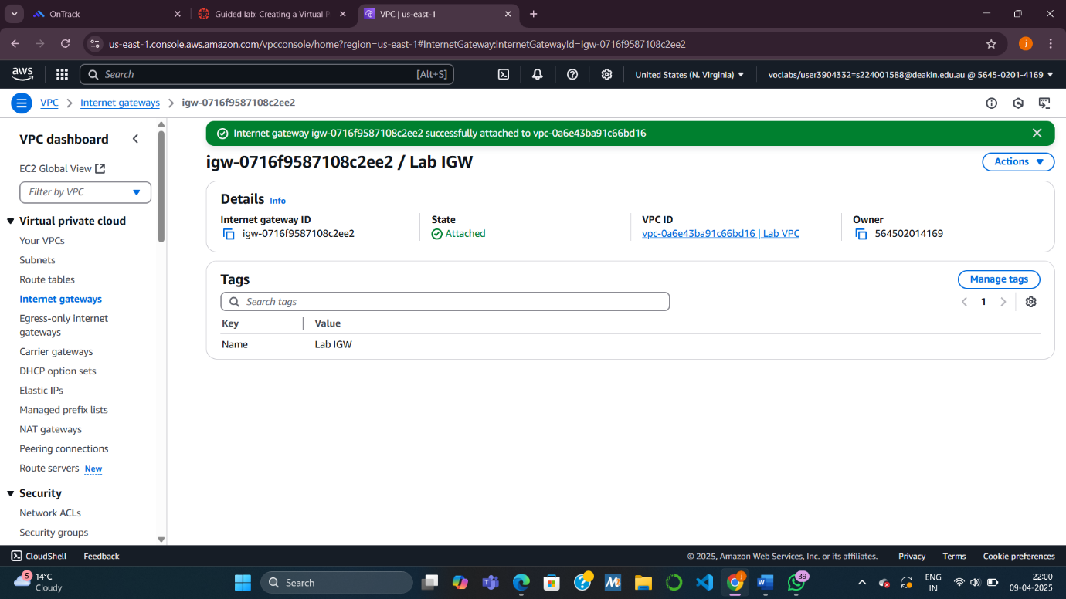

**Task 4: Configuring Route Tables**

Route tables define how traffic moves within and outside your VPC.

**4.1 Created Private Route Table**

* **Why:** Handles internal communication within VPC.
* **What I did:** Renamed the default route table to “Private Route Table”.

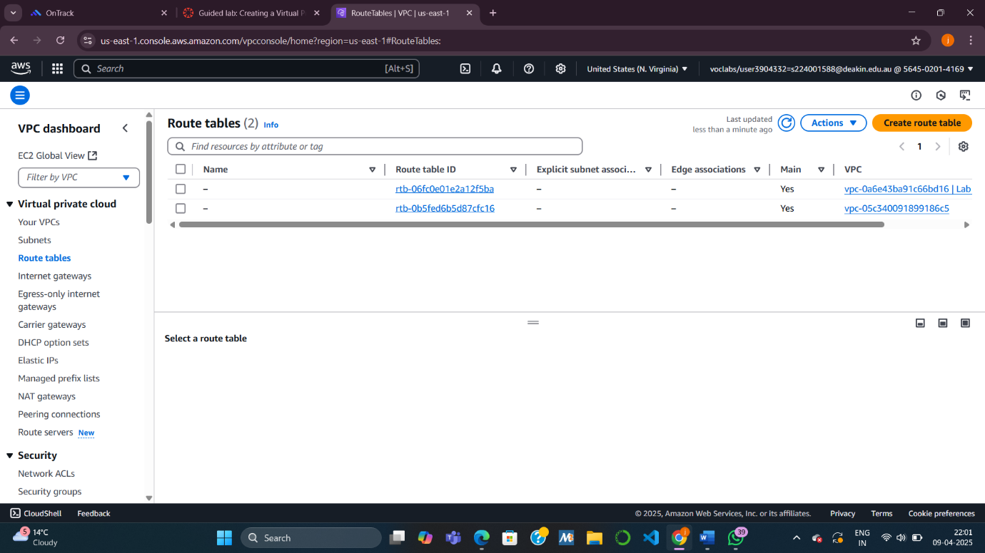

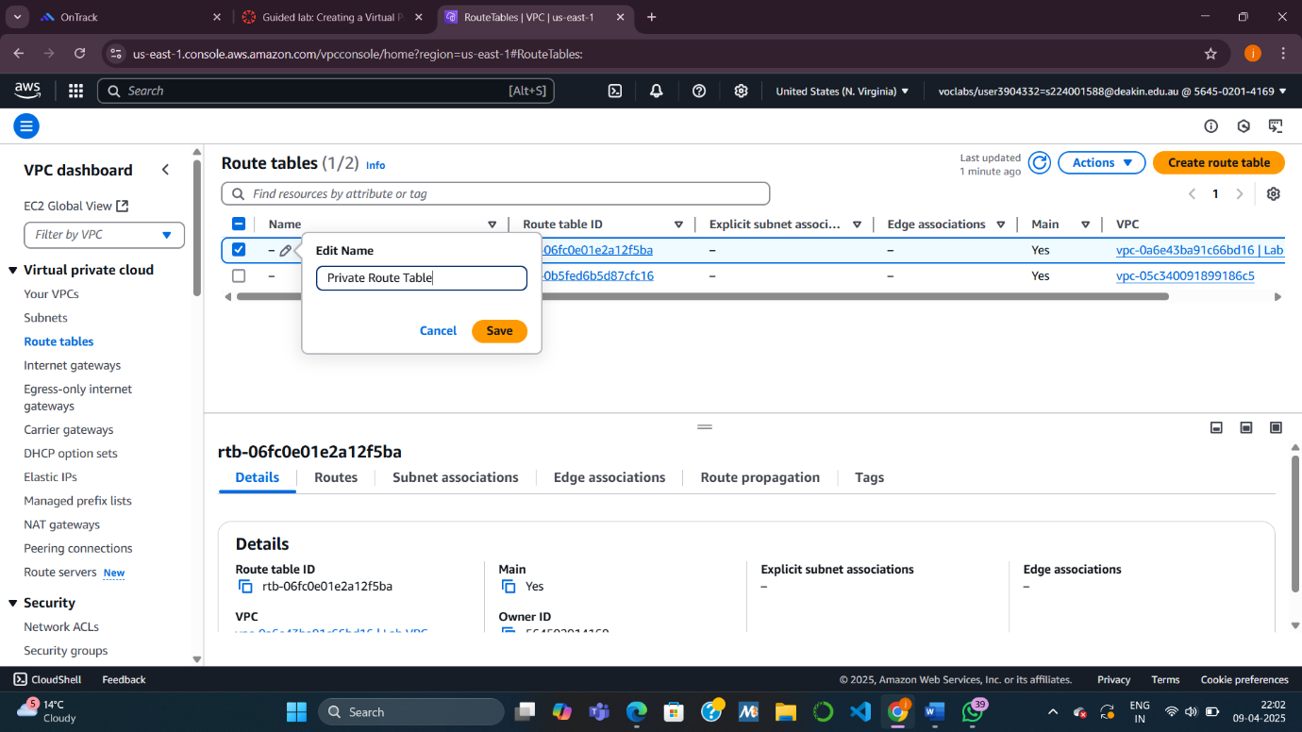

**4.2 Created Public Route Table**

* **Why:** Allows internet-bound traffic from the public subnet.
* **What I did:**
  + Created a new route table.
  + Added a route (0.0.0.0/0) to the IGW.
  + Associated this table with the public subnet.

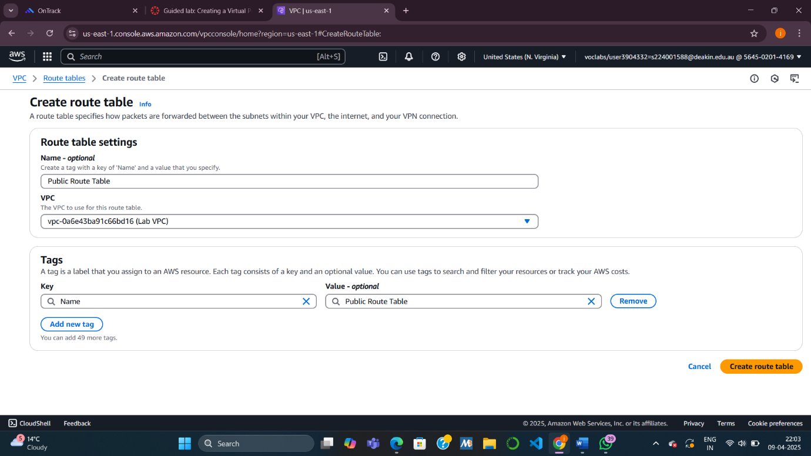

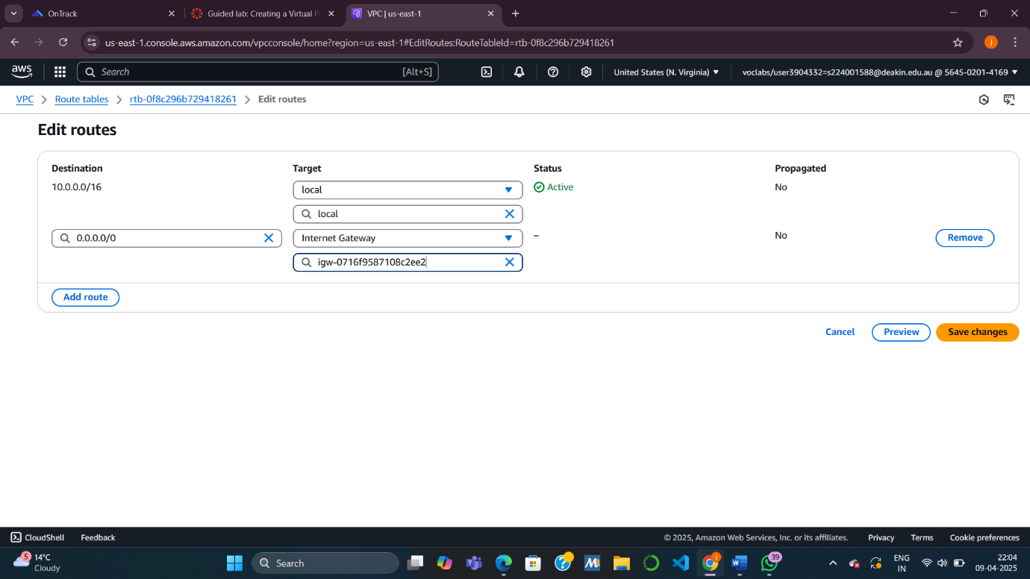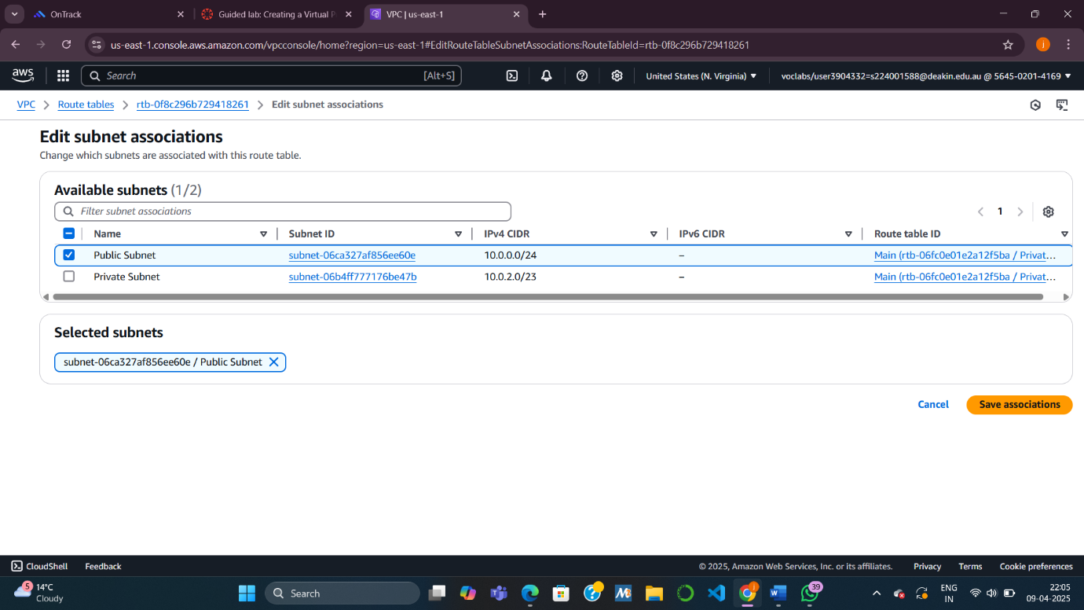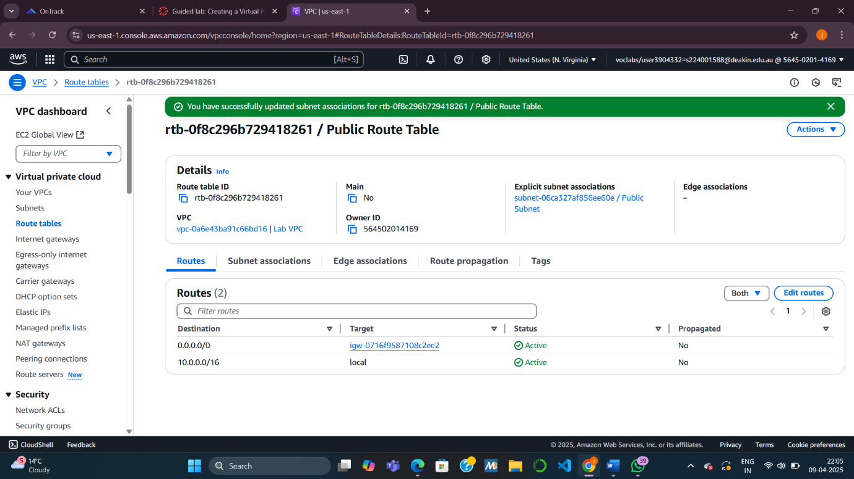

**Task 5: Creating a Security Group for the App Server**

A **security group** is a virtual firewall for EC2 instances.

* **Why:** To allow HTTP (web) access to your server from anywhere.
* **What I did:**
  + Created a security group called App-SG.
  + Added an inbound rule to allow HTTP traffic from 0.0.0.0/0.

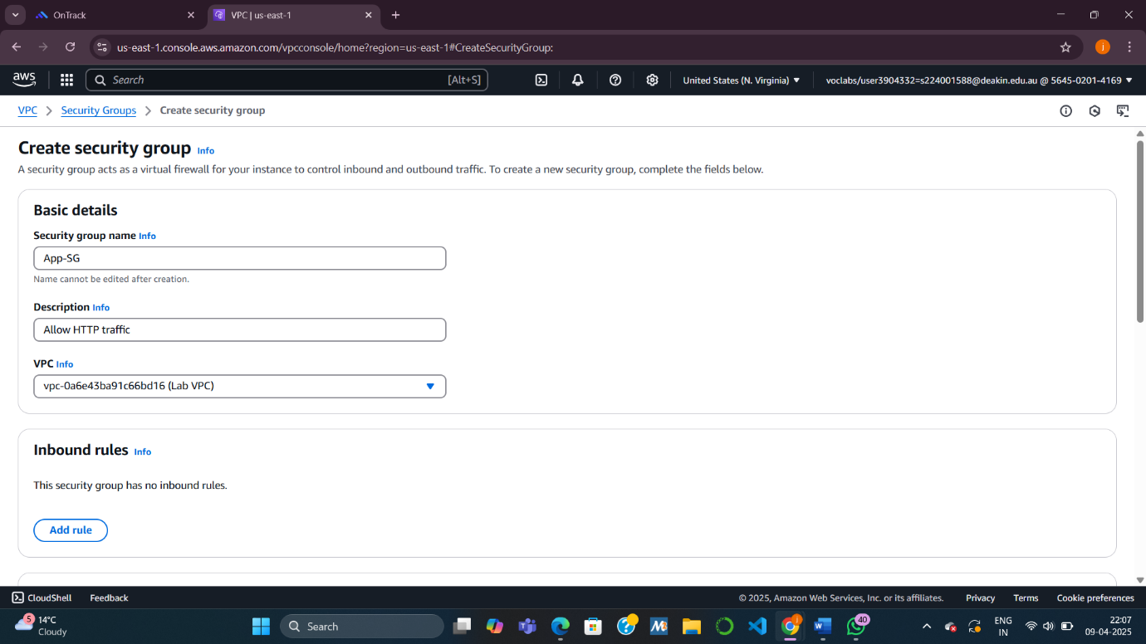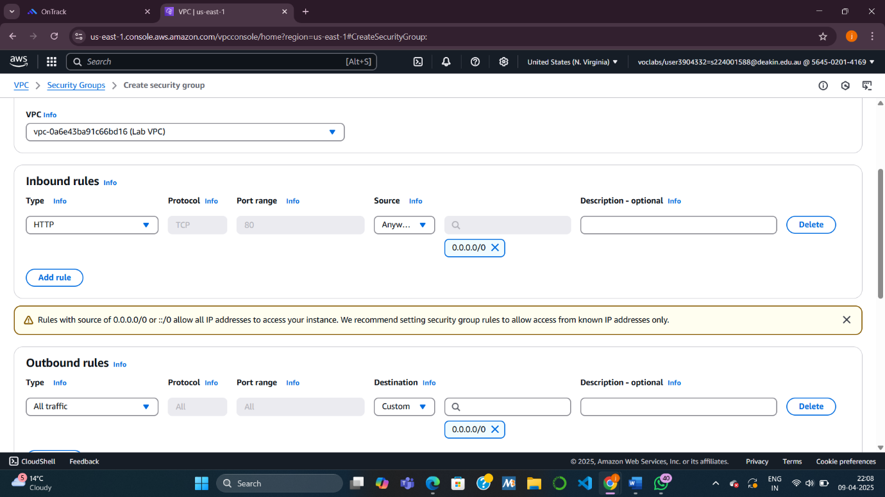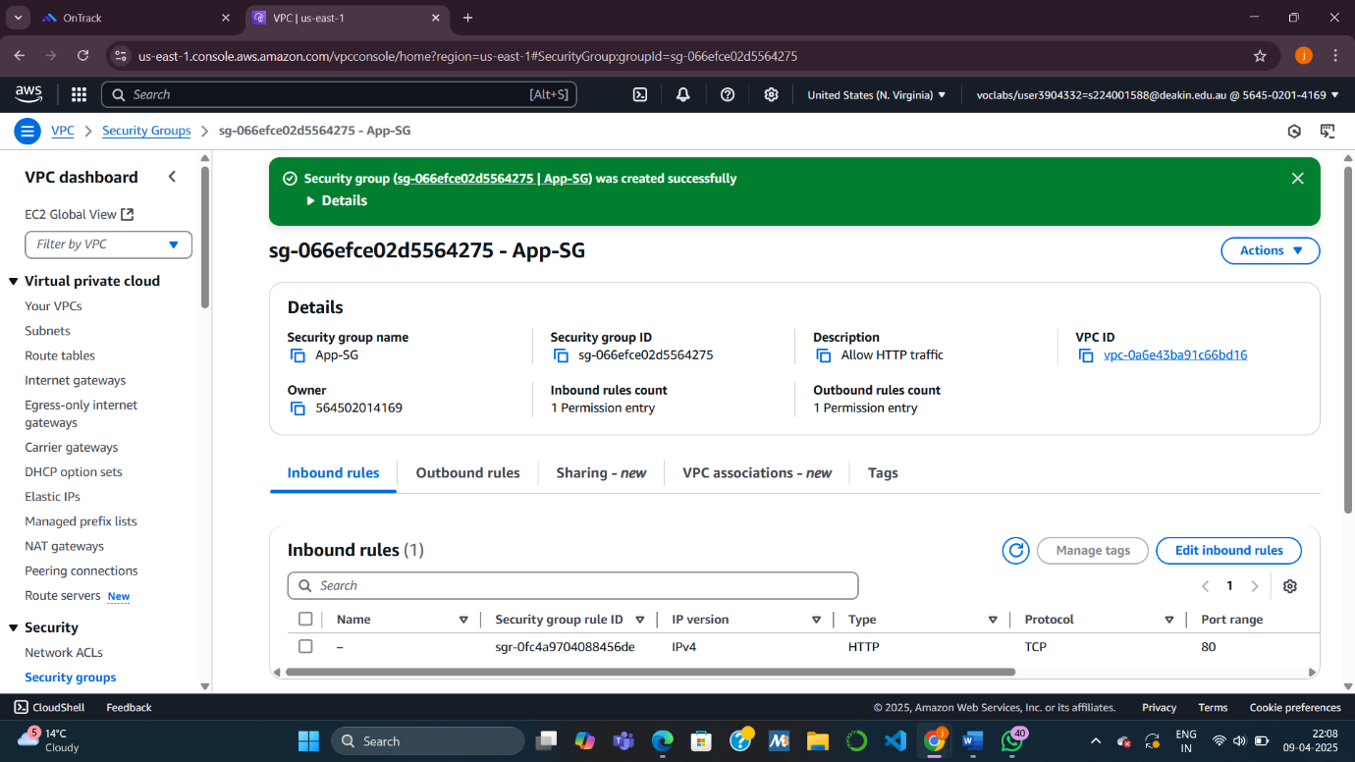

**Task 6: Launching an Application Server**

You launched an **EC2 instance** (virtual server) in the public subnet.

* **Why:** To test your VPC setup and confirm the web app is accessible.
* **What I did:**
  + Chose the Amazon Linux 2023 AMI.
  + Used subnet: Public Subnet.
  + Applied the App-SG security group.
  + Used a startup script to install a web app and Apache web server.
  + Accessed the app using the **Public IPv4 DNS** of the instance.
* 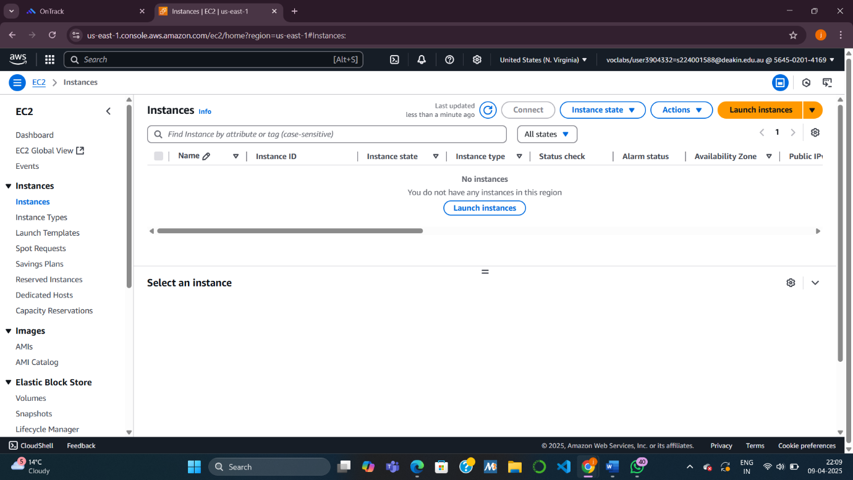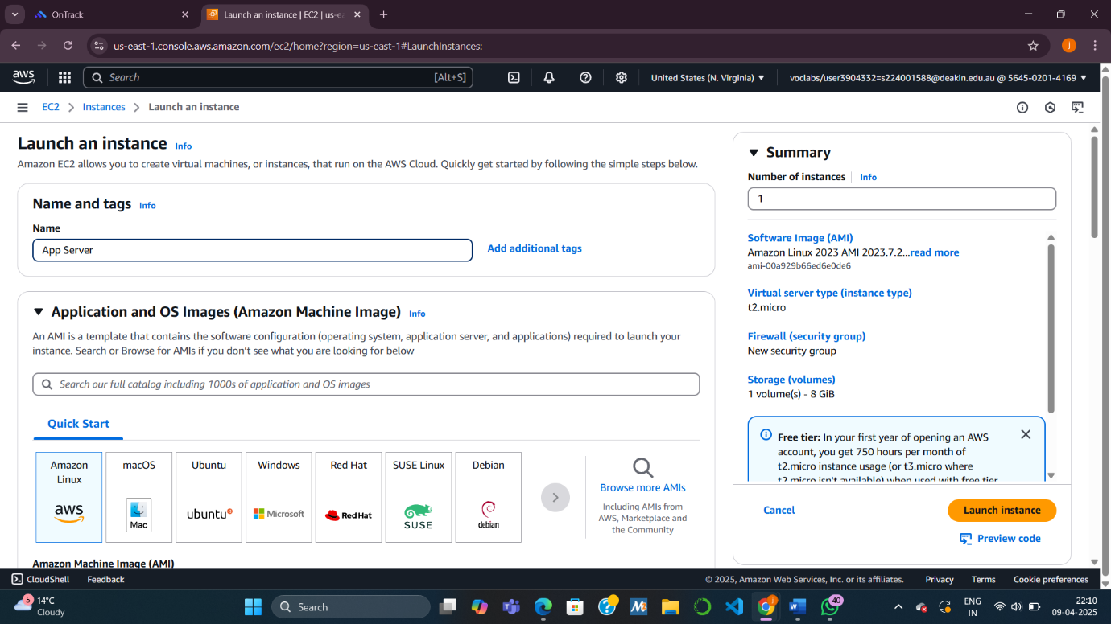

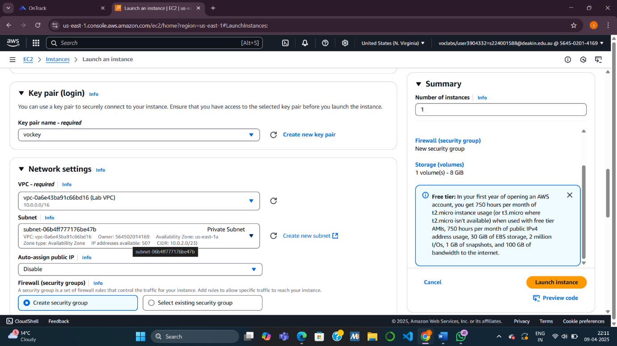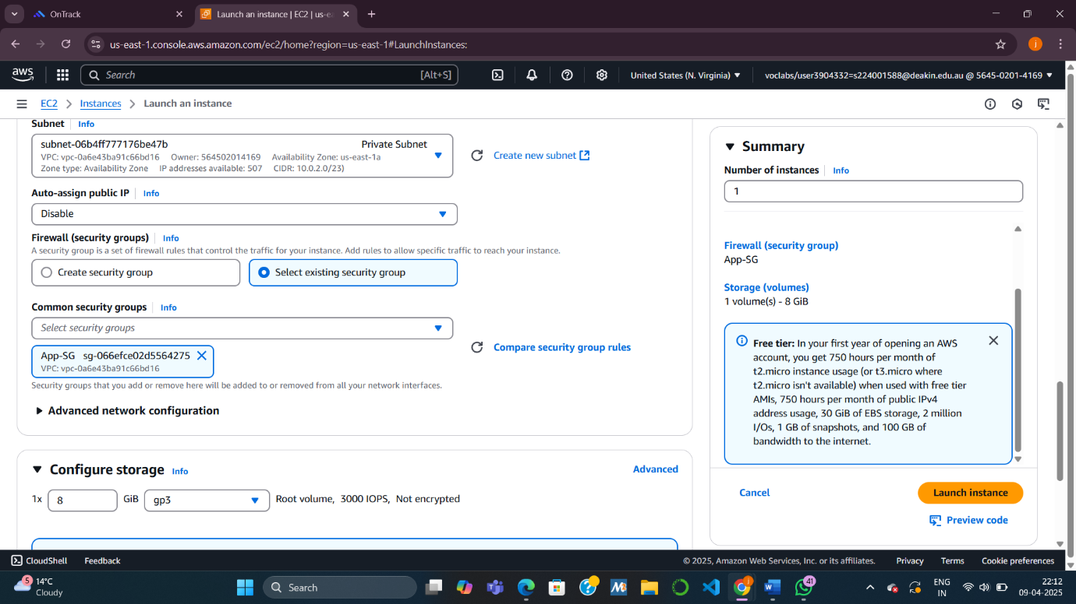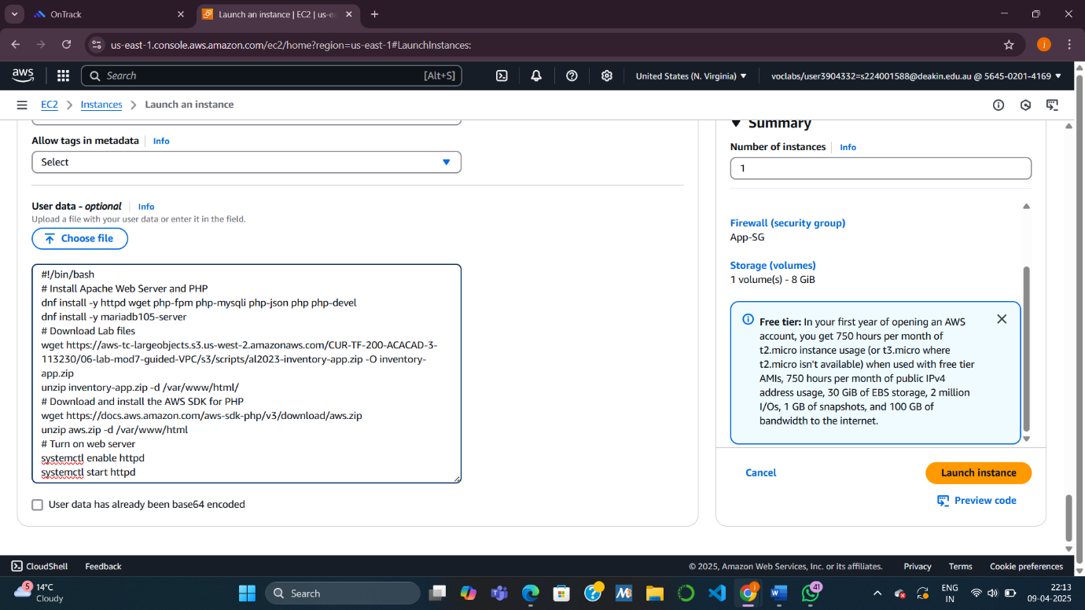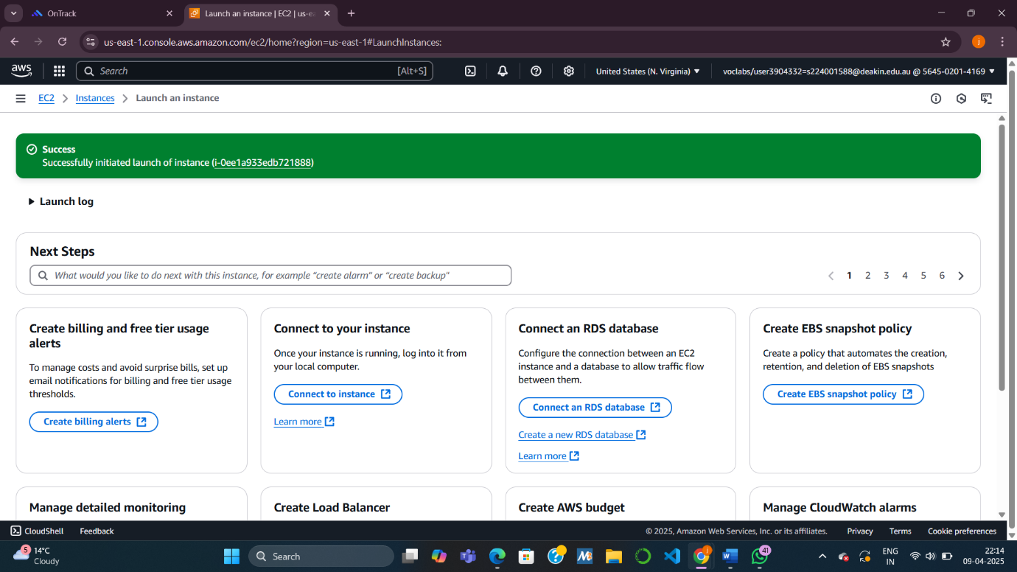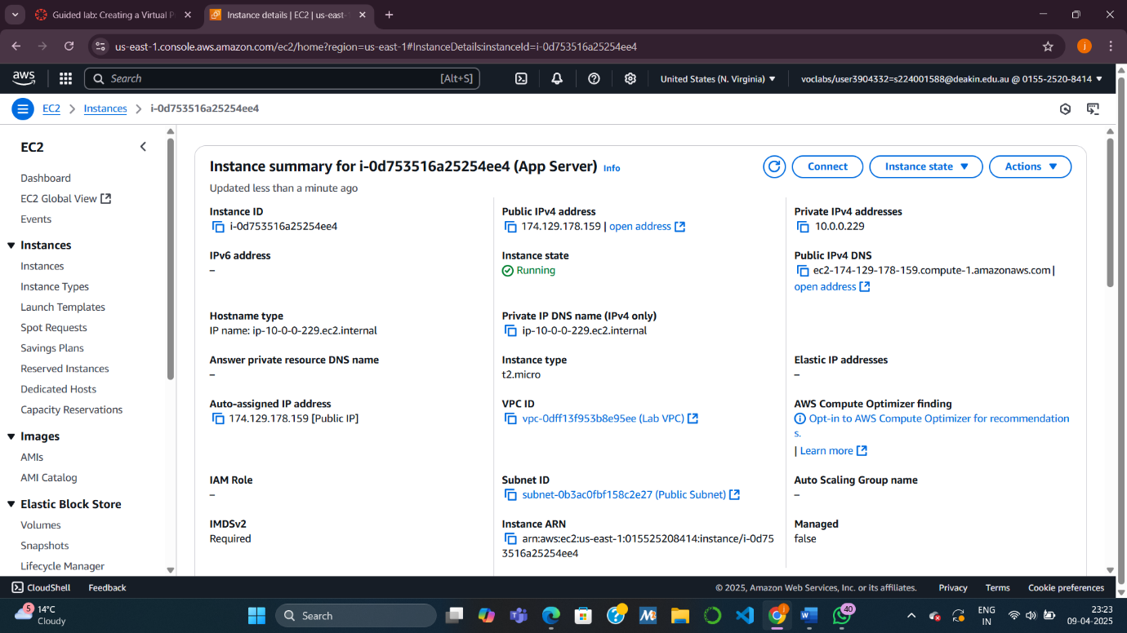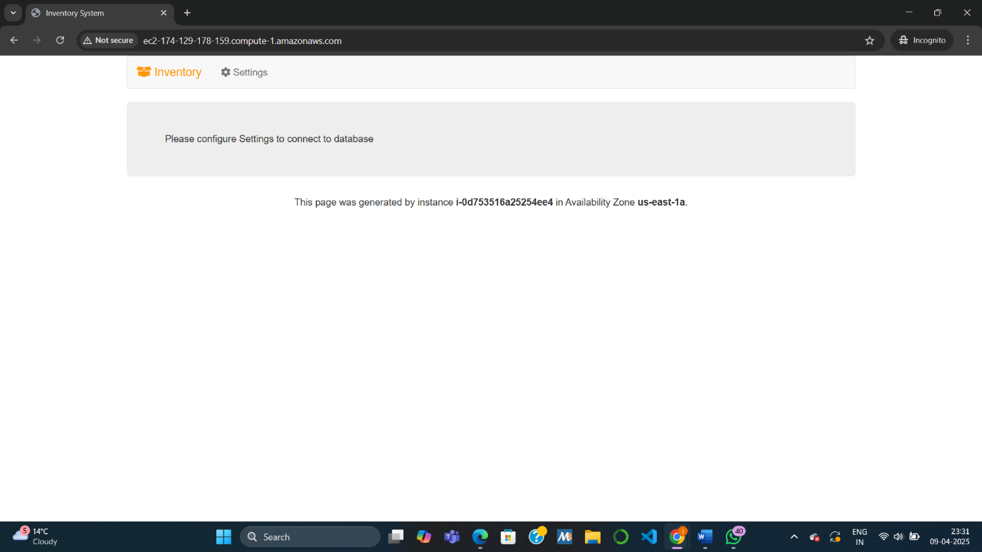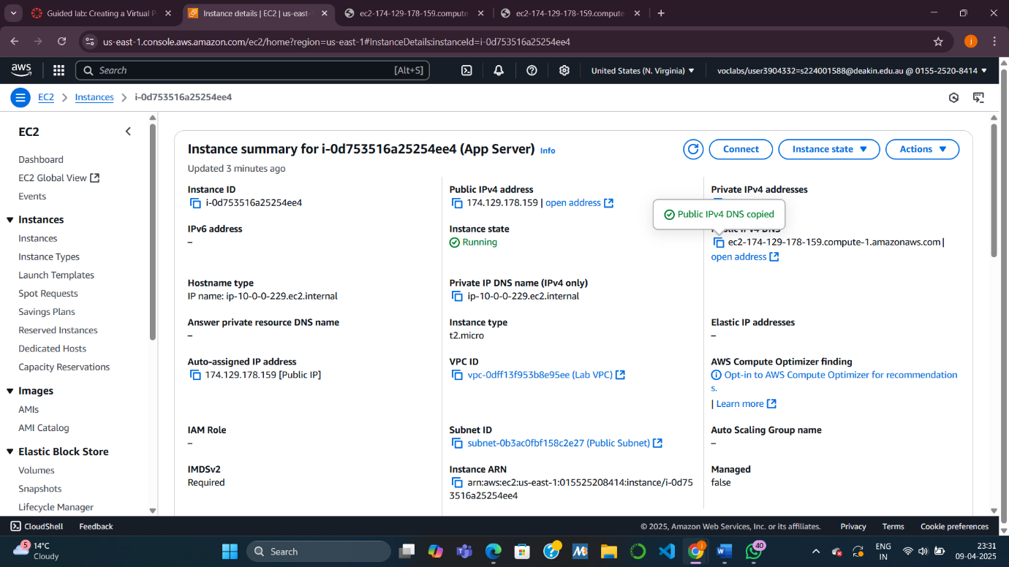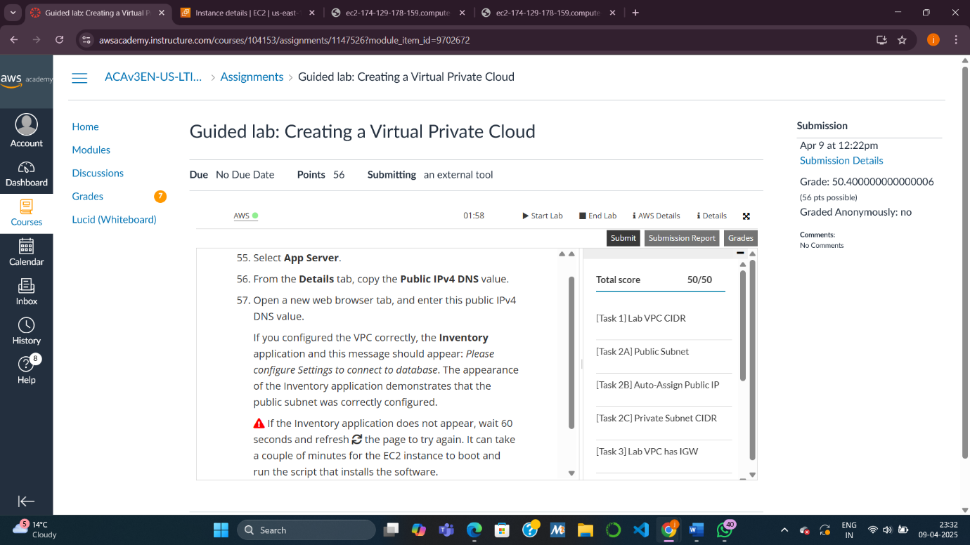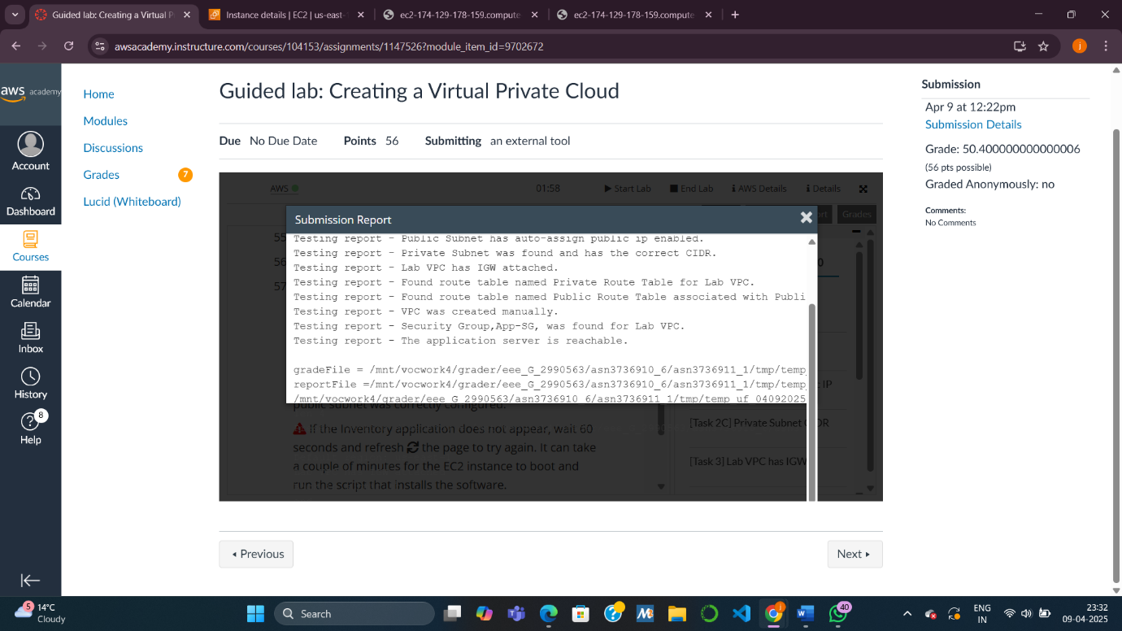

KNOWLEDGE CHECK MODULE 7

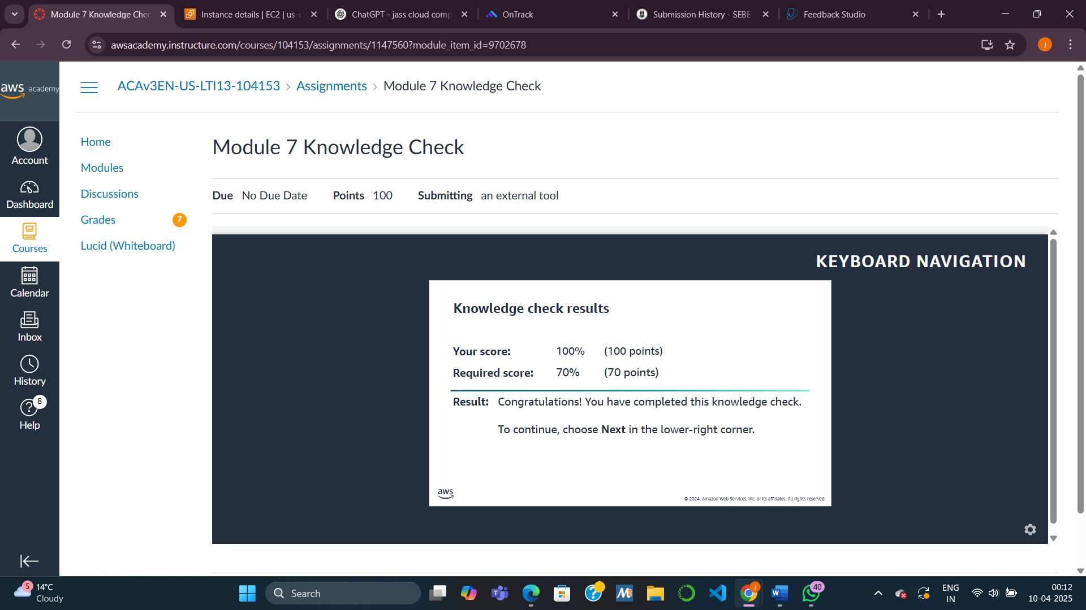

. What is the difference between an Internet Gateway and a NAT Gateway?

* Internet Gateway (IGW):

Allows instances with public IPs in a public subnet to access the internet and be accessed from the internet.

Used for inbound and outbound internet traffic.

* NAT Gateway:

Allows instances without public IPs in a private subnet to access the internet but blocks inbound traffic from the internet.

Used for outbound-only access from private subnets.

. How do you make a subnet public?

To make a subnet public:

* Attach an Internet Gateway to the VPC.
* Create or update a route table with a route to 0.0.0.0/0 (internet) via the Internet Gateway.
* Associate the route table with the subnet.
* Enable auto-assign public IP for instances launched in that subnet.